**Project Design Phase – II**

**Data Flow Diagrams & User Stories**

|  |  |
| --- | --- |
| Date | 15 October 2022 |
| Team ID | PNT2022TMID02964 |
| Project Name | Personal Expense Tracker |
| Batch Number | B4-4M6E |

**Data Flow Diagrams:**

A Data Flow Diagram (DFD) is a traditional visual representation of the information flows within a system. A neat and clear DFD can depict the right amount of the system requirement graphically. It shows how data enters and leaves the system, what changes the information, and where data is stored.

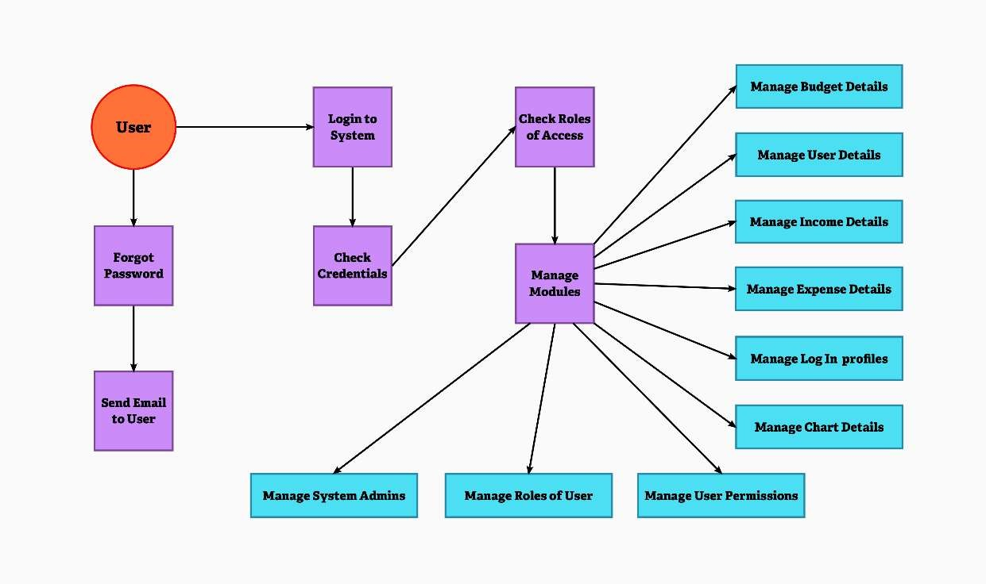

**User Stories:**

|  |  |  |  |  |  |  |
| --- | --- | --- | --- | --- | --- | --- |
| User Type | Functional  Requirement (Epic) | User  Story  Number | User Story / Task | Acceptance criteria | Priority | Release |
| Customer  (Mobile user & Web user) | Registration | USN - 1 | As a user, I can register for the application by entering my email, password, and confirming my password. | I can access my account / dashboard. | High | Sprint - 1 |
|  |  | USN - 2 | As a user, I can track my expenses and manage my monthly budget. | I can track my expenses and manage my monthly budget. | High | Sprint – 3 |
|  |  | USN - 3 | As a user, I can see if there is an excessive expense and if there is such condition, I will be notified via e-mail. | I can receive e-mail, if there is an excessive expense. | Low | Sprint – 3 |
|  | Login | USN - 4 | As a user, I can login to user dashboard and see the information about my incomes and expenses. | I can login to user dashboard and see the information. | High | Sprint – 1 |
|  | Dashboard | USN - 5 | As a user, I can enter my income and expenditure details. | I can view my daily expenses. | High | Sprint – 2 |
| Customer Care  Executive |  | USN – 6 | As a customer care executive, I can solve the log in issues and other issues of the application. | I can provide support or  solution at any time 24*7 | Medium | Sprint – 4 |
| Administrator | Application | USN - 7 | As an administrator, I can upgrade or update the application. | I can fix the bug which arises for the customers and users of the application. | Medium | Sprint - 4 |